


MoodLearning, Inc. 2016. Serbizhub Banking User Manual, v.1

Audience

This document aims to guide an UP Credit Cooperative user in using the Serbizhub Banking. The graphical user interface will help an UP Credit Cooperative user to navigate Serbizhub Banking and its advanced features. This will hopefully guide you around some common challenges that users of Serbizhub Banking may encounter.

The System

Installation and Logging In

- Installation of Serbizhub Banking is done by MoodLearning’s Technical Support Team.
- Log in to the system using the account information provided.
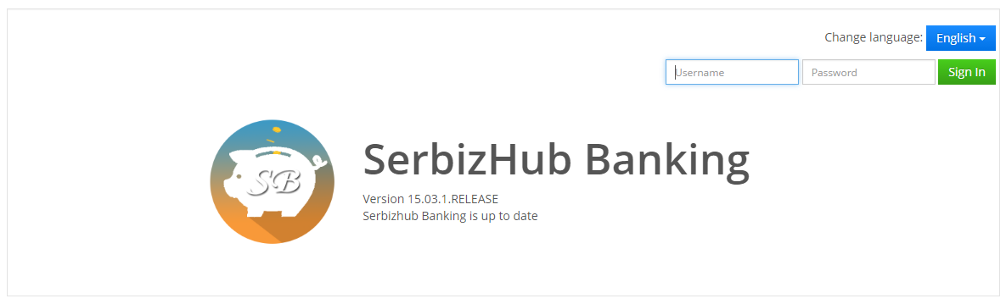Figure 1. Login Panel

Procedure:
- Enter the username in the username field and the password in the password field.
  - The system will validate the entered username and password. If valid, the user will be redirected to the homepage.
  - However, if the entered username and password is invalid, the user cannot access the system. The error message below will appear. (Figure 2)
Figure 2. Error Message
- Once the username and password are validated, it will redirect to the dashboard. To sign out, go to username > sign out.
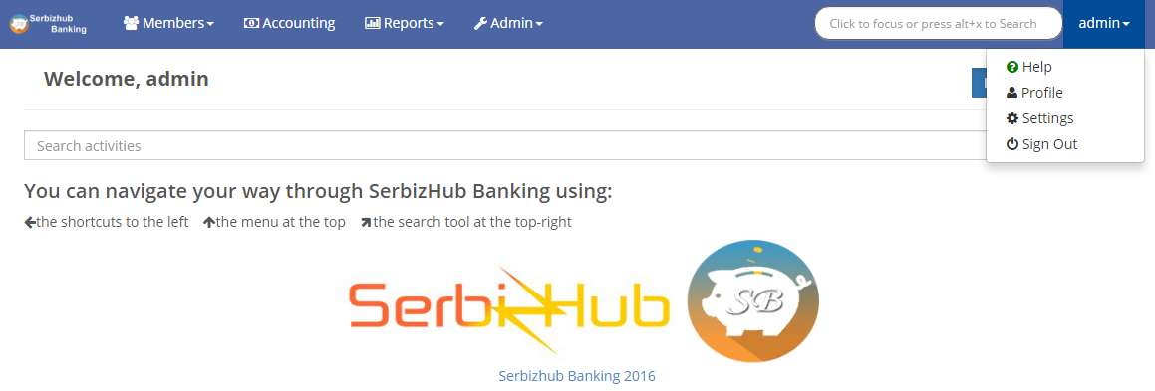

Figure 3. Log out

User Roles

Several default user roles with predefined access levels can be used. Administrators can create new users, assign their roles and restrict their access to certain modules and/or screens. The following are predefined roles available in Serbizhub Banking, which can be edited of modifies by Administrator based on UP Credit Cooperatives’ preferences:
Role | Description
Super User | The system administrator who have the privilege to administer and maintain the system.
Manager | This user have the privilege to view the entire system and approve loans
Membership | This user can add and edit member profiles
Loans | This user have the privilege to apply to new loans and edit existing loans
General Manager | This user have the privilege to view the entire system
Accounting | This user have the privilege to administer the accounting side of the system and view and export the accounting reports
Cashier | This user can make repayment to the existing loans
Table 1. User Roles

Modules

There are six (6) modules in the base installation of Serbizhub Banking. These modules are currently available in cloud installation.
Table 2. Modules
Module | Description
Coop Membership Module | Enables user to add new members and configure all the necessary information given to the cooperative.
Loan Management Module | Enable users to apply and configure loans.
Savings Account Module | Enable users to open and configure savings account. Loan manager is the one handling this module.
Accounting Module | Enable users to manage journal entries.
Reports Module | Enables users to run reports needed, this can also be exported to different format such as PDF and CSV.
Admin Module | Enables user to configure products and basic settings. Enables users to manage and add users configure data tables and the drop down values.
Table 3 below is a summary of default user roles with access to different modules.
Table 3. User Roles Summary
User Roles | Membership | Transaction | Loan Management | Savings Account | Reports | Accounting | System  Admin
Super User | ✔ | ✔ | ✔ | ✔ | ✔ | ✔ | ✔
General Manager | ✔ | ✔ | ✔ | ✔ | ✔ | ✔ | ✔
Manager |  | ✔ | ✔ | ✔ | ✔ | ✔ | ✔
Membership | ✔ |  |  |  | ✔ |  | ✔
Loans |  |  | ✔ |  | ✔
Accounting |  |  |  |  | ✔ | ✔
Cashier |  |  |  |  | ✔

3.0 Membership

Membership module is a part of the system where the membership manager can create and manage members.
If the user successfully logged in the system, it will redirect to the dashboard.
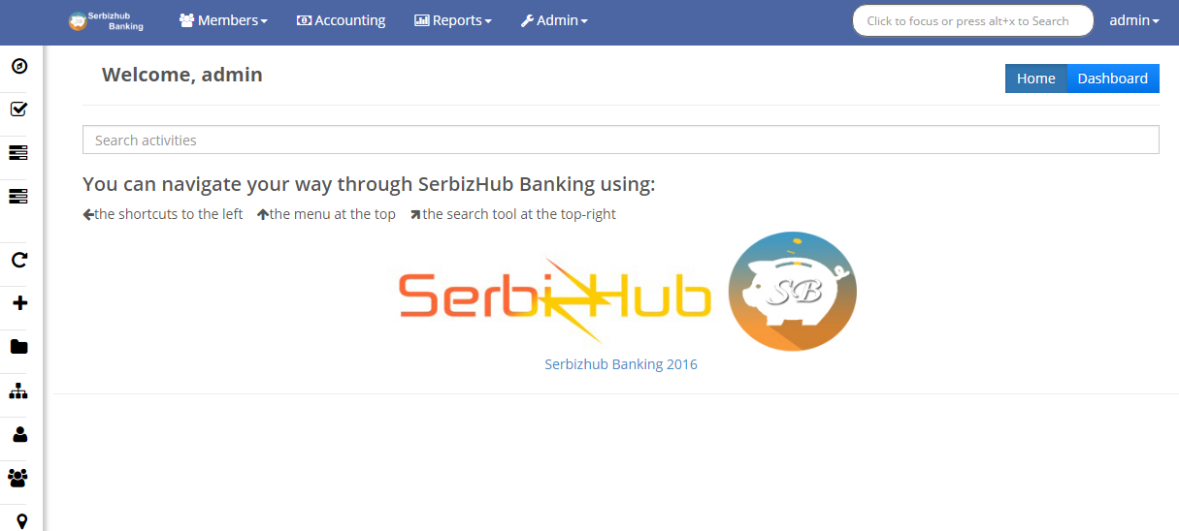
Figure 4. Dashboard

3.1 View Member
To view an existing member in the system, go to Members > Members > Name of the Member you want to view, you can also search the name of the member using the search field provided. The system will then redirect to the Members’ profile. See figures below.
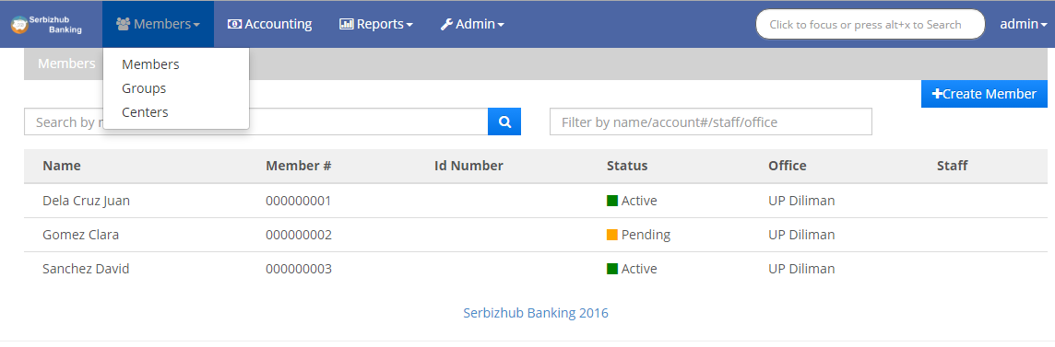

Figure 5. Members
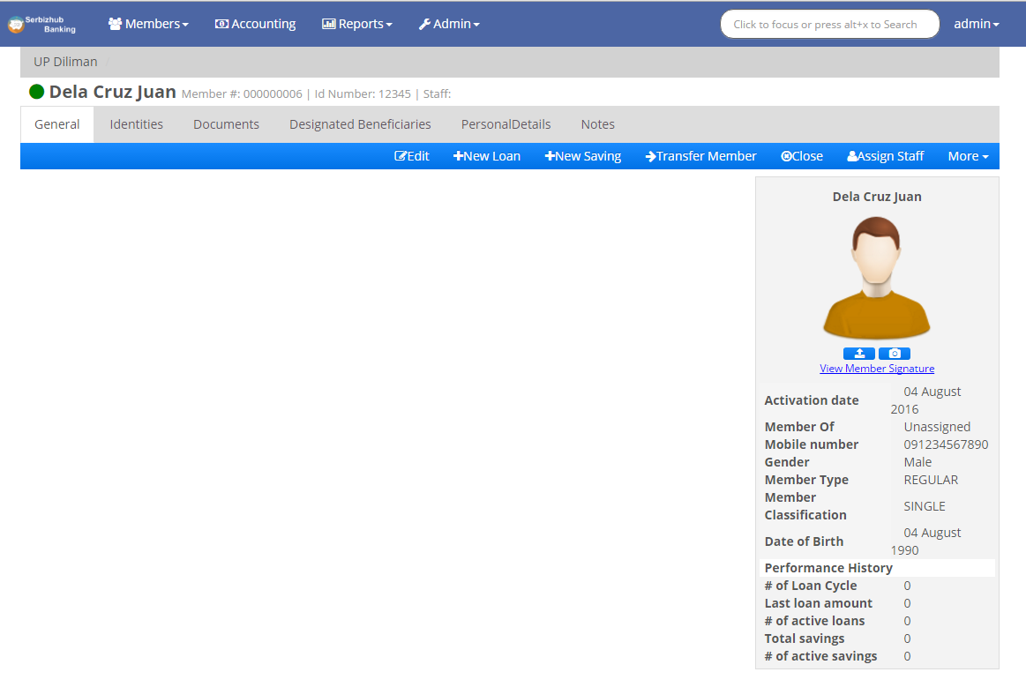Figure 6. Members’ Profile
The members’ profile contains the list of all the members’ loans and savings, if there are any. The loan administrator can apply the members’ new loan through the members’ profile.

3.2 Manage Member

3.2.1 Create Member
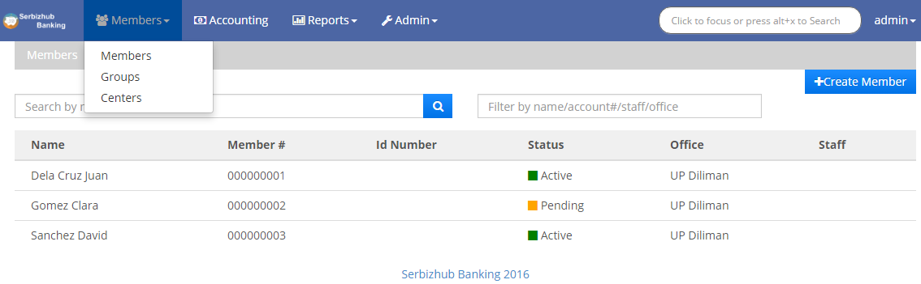To create a new member, go to Members > Members > Create member ( ). The system will redirect the user to the create member page. Fill in all the necessary and required fields and click submit.

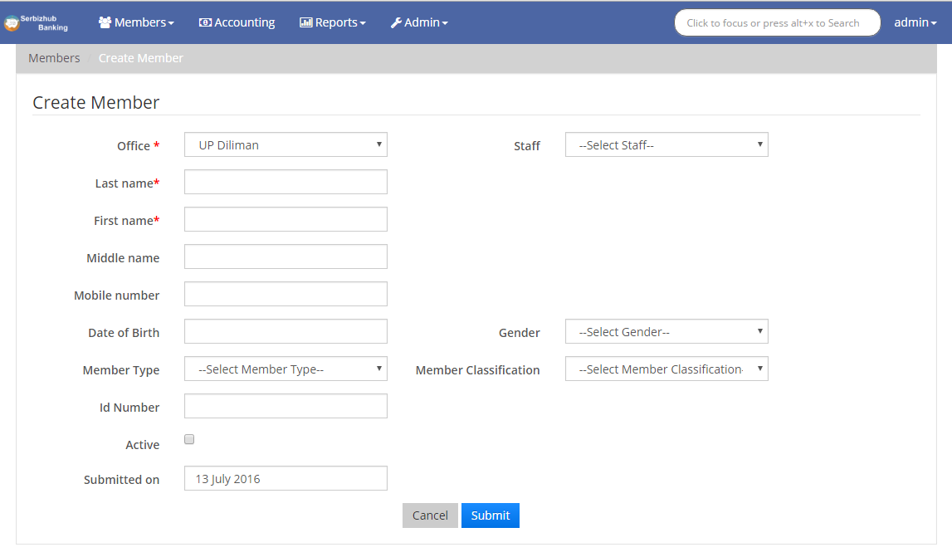
Figure 7. Create Member

Figure 8. Create member fields
The user can also use the navigation at the left side of the screen to add new member/s. Please see figure below.

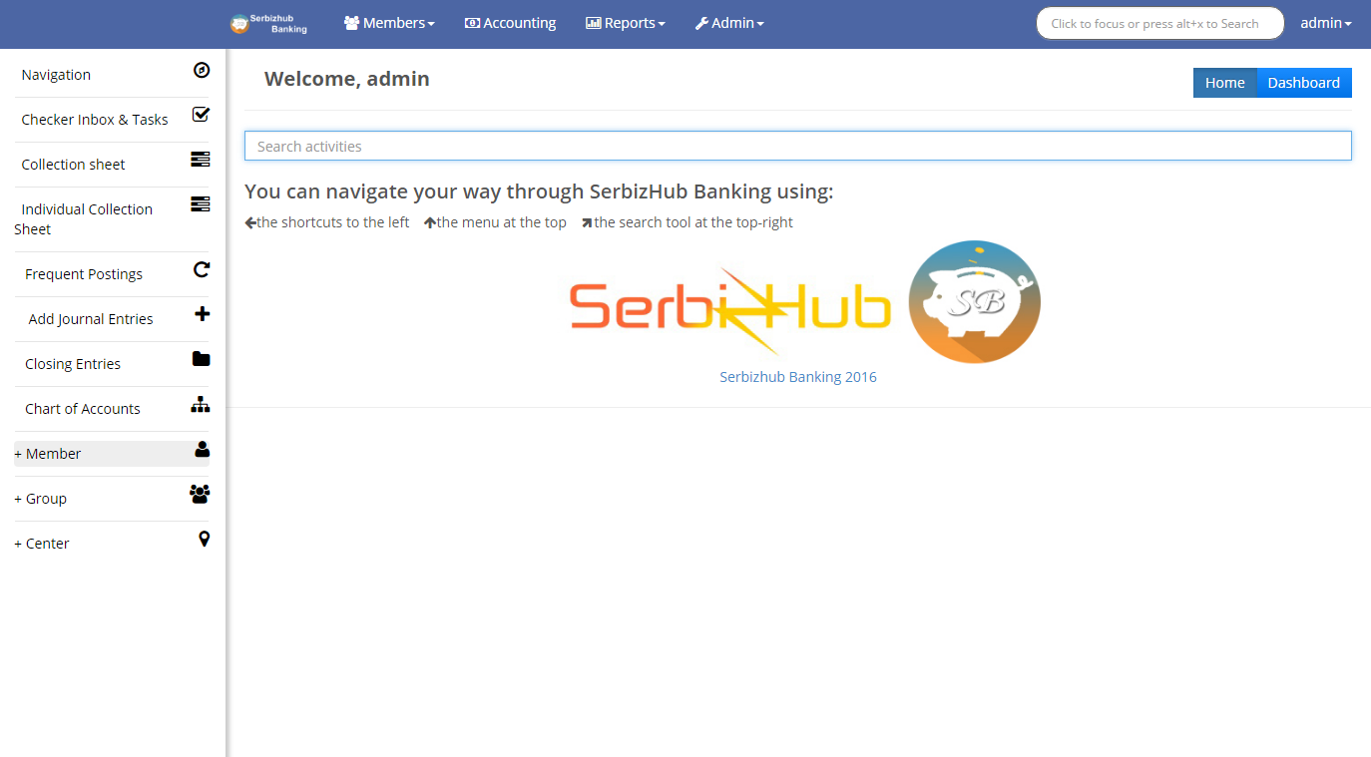
Figure 9. Alternative Create Member

This will also redirect the user to Figure 8.

3.2.2 Edit Member

To edit a member, go to Member > Member > Name of the Member > General Tab > Edit. Edit all the fields needed then click Submit. See Figure 10.
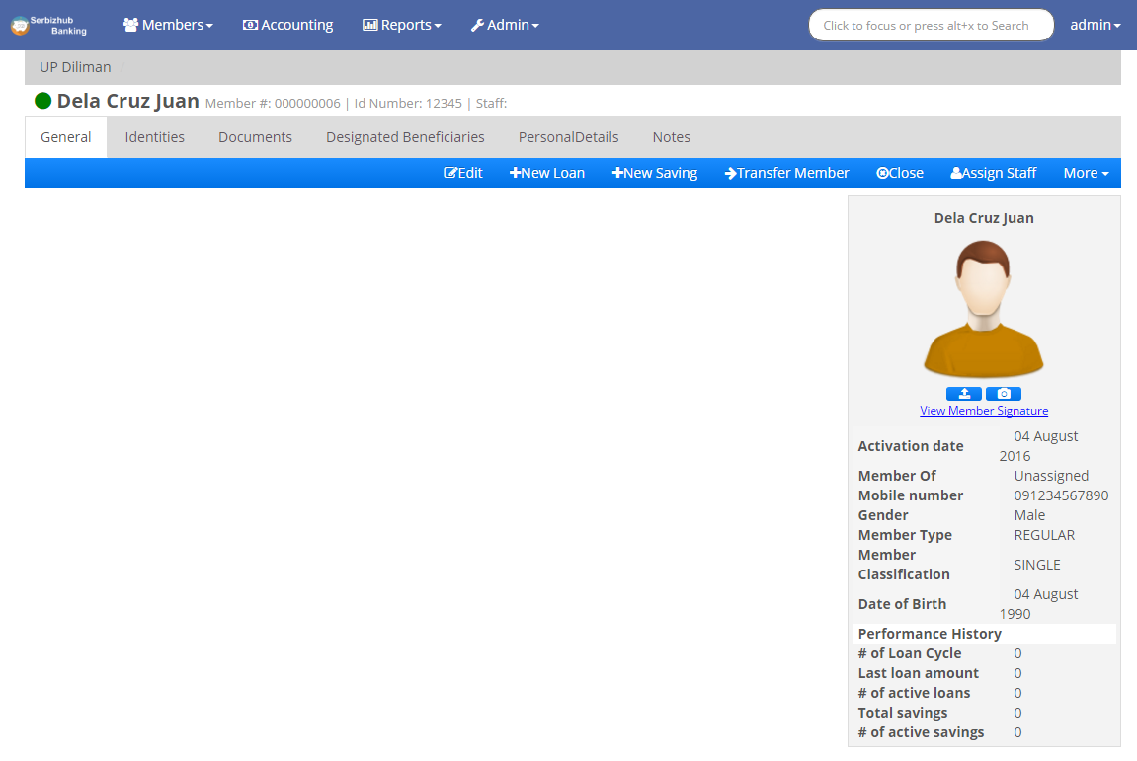

Figure 10. Edit Member

3.2.3 Upload Members’ Image

There are two ways to set an image for a member:
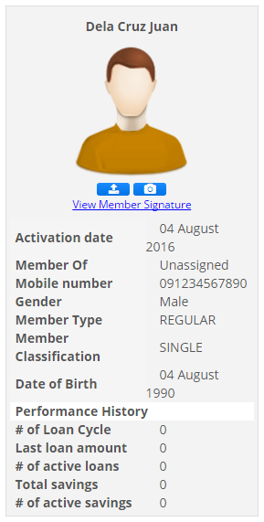
- To upload a members’ image, go to Members > Members > Name of the Member > Upload (). (Please refer to Figure 11). A pop up window will appear. Click Choose file, this will let the user locate file to be uploaded. Then click Upload. (See Figure 12)

Figure 11. Upload Members’ Image

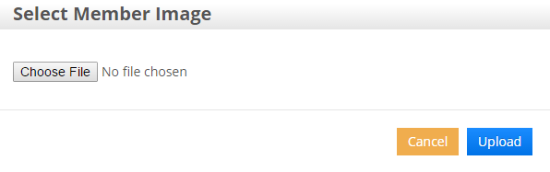

Figure 12. Choose File

- To capture a members’ image using real-time, go to Members > Members > Name of the Member > Capture (). (Please see Figure 13). A pop up window will appear to capture the image using the computers’ webcam. Click Capture > Upload. (See Figure 14).

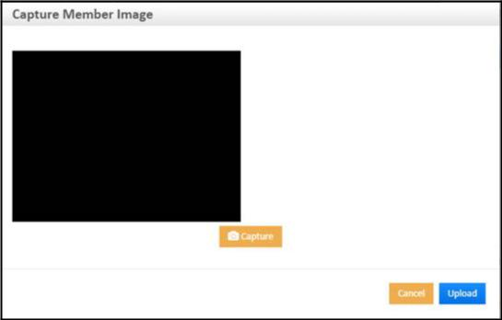Figure 13. Capture Image

Figure 14. Capture & Upload

3.2.4 Upload Members’ Signature

To upload a members’ signature, go to Members > Members > Name of the Member > More. A drop down will appear. (Please see Figure 15) Click Upload Member Signature > Choose File > Upload. (See Figure 16)
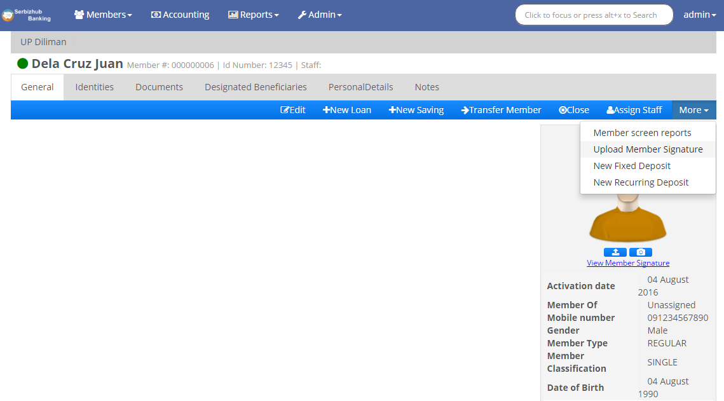

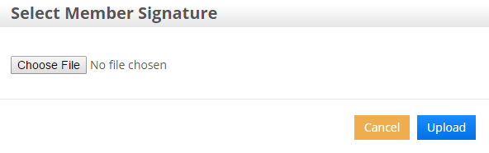
Figure 15. Upload Signature
Figure 16. Select Member Signature

3.2.5 Add Identities

To add members’ identities, go to Members > Members > Name of the Member > Identities Tab > Add. Fill in the necessary and required fields the click the Submit button. (See Figure 17 to 18).
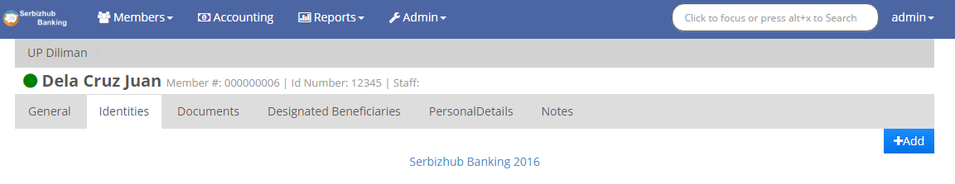

Figure 17. Identities
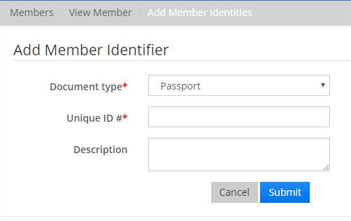
The user can upload identity documents as supporting documents to the inserted ID.

Figure 18. Member Identifier
In the actions column, click the ( ) icon to add document. Fill in the required fields > Choose File to locate the file to be uploaded the click Submit. To download the uploaded file, click ( ) icon and to delete the added identity document, click ( ). (See Figure 19)
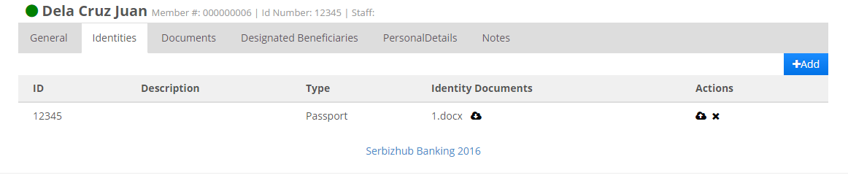

Figure 19. Actions

3.2.6 Adding Documents

To upload a members’ document, go to Members > Members > Name of the Member > Documents Tab > Upload. Fill in all the necessary and required fields. Click Choose File to locate the file to upload then click Submit. See Figure 20 to 21.

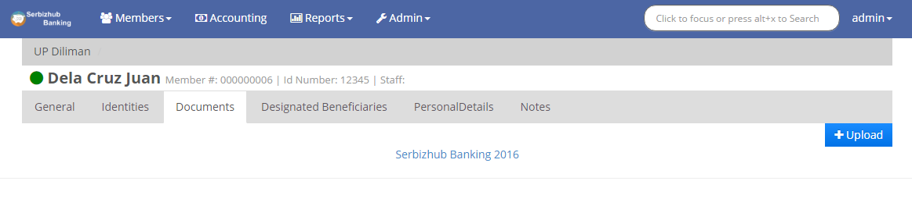

Figure 20. Adding Document
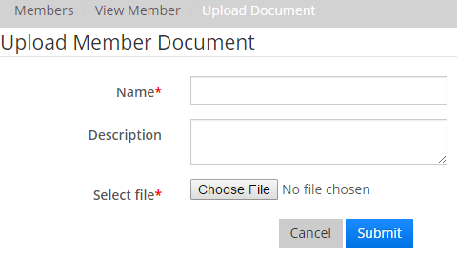

Figure 21. Upload Member Document
In the actions column, click the () to download the uploaded document or click () to delete the document. Please refer to Figure 22.
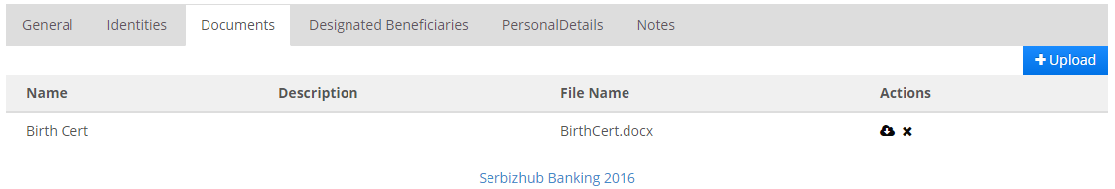

Figure 22. Documents and Actions

3.2.7 Adding Beneficiaries

To add Beneficiaries, go to Members > Members > Name of the Member > Beneficiaries Tab then click Add. See Figure 23. Fill in all the required fields then click Submit.
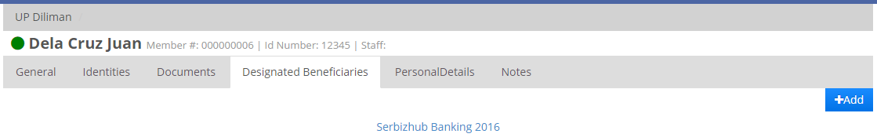
Figure 23. Adding Beneficiaries
Per member, there will be five (5) allotted slots for the beneficiaries.
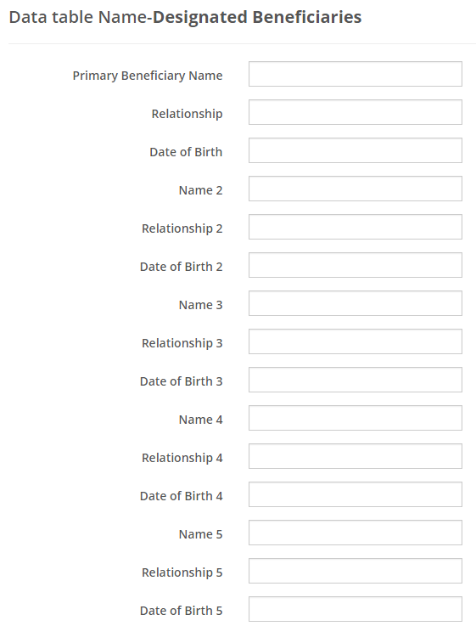

Figure 24. Beneficiary Fields

3.2.8 Adding Personal Details

To add Personal Details of a member, go to Members > Members > Name of the Member > Personal Details Tab > Add. See Figure 25. Fill in all the necessary and required fields then click Submit. Please refer to Figure 26.
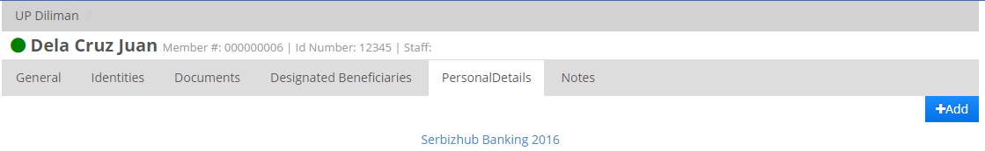
Figure 25. Adding Personal Details

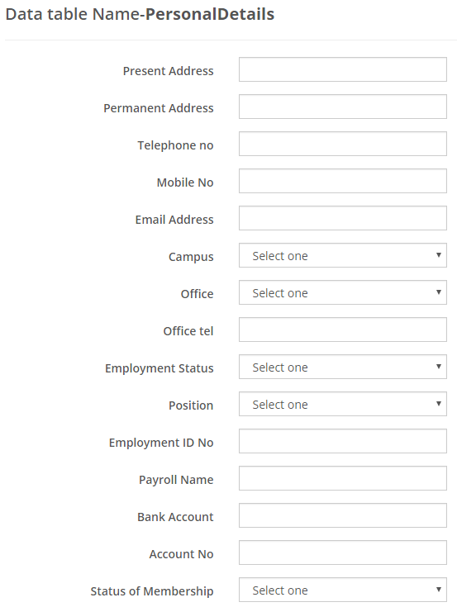

Figure 26. Personal Details fields
Note: All the available fields for adding Personal Details are predefined by the membership administrator of UP Credit Cooperative.
Beneficiary and Personal Details can be edited by clicking Edit () or delete all the information added by clicking Delete All (  ).

3.2.9 Adding Notes

To add notes, go to Members > Members > Name of the Member > Notes Tab > Enter Note then click Add. See Figure 27.
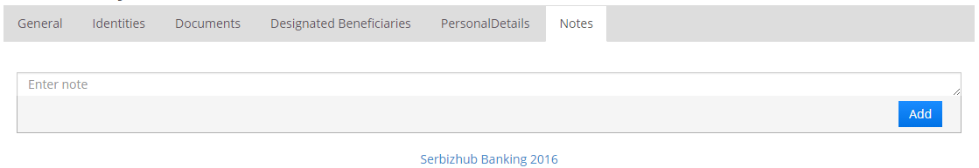
Figure 27. Adding Notes
Once added, a screen similar below will appear:
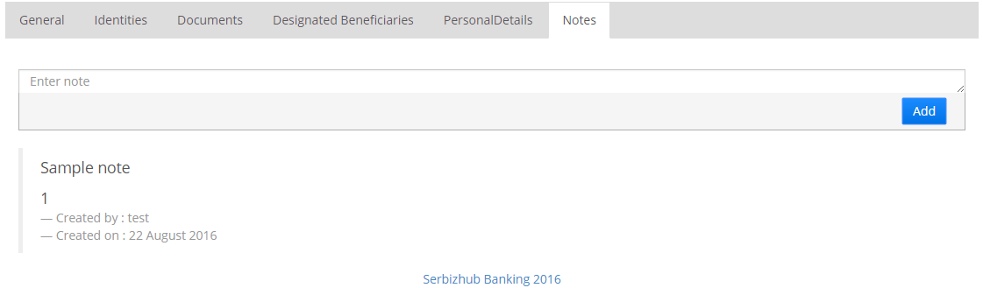
Figure 28. Added Note
Note: The user cannot delete the notes once it is added.

3.2.10 Changing Members’ Status

To change the status of the member, go to Member > Member > Name of the Member > General Tab > Close. Fill all the required fields then click Submit. This will change the status of the member from “Active” to “Close”. See figures 29 to 30.

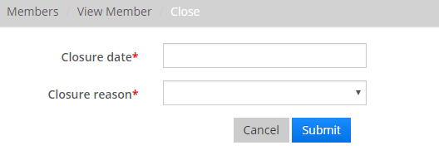
Figure 29. Close Member

Figure 30. Closure Date and Reason

3.2.11 Transfer Member

To transfer member from one unit to another, go to Member > Member > Name of the Member > General Tab > Transfer Member then select the desired unit to transfer and fill the transfer reason field then click Submit. Please refer to the Figures 31 to 32.

Figure 31. Transfer Member
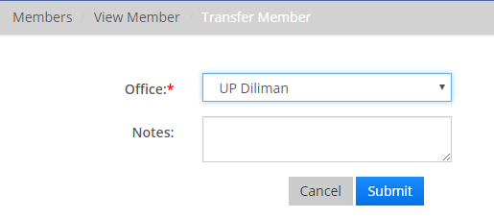
Figure 32. Transfer to another Unit

3.2.12 Assign Staff

To assign staff to a specific member, go to Member > Member > Name of the Member > Assign Staff. Pick the desired staff then click Submit. See figures 33 and 34.

Figure 33. Assign Staff
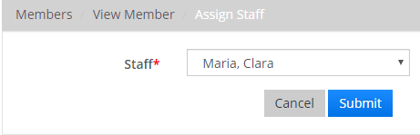
Figure 34. Assigning Staff

Loan Management

The loan management module is a comprehensive loan system where the loan administrator can manage the loans of the members. Once the loan is applied by the loan manager, the relevant General Manager can approve or reject the application.

New Loan

To apply for a new loan of the member, go to Member > Member > Name of the Member > New Loan. This will redirect the loan manager to a new page for selecting a loan product the member requests to apply. Please refer to figure 35 to 37.
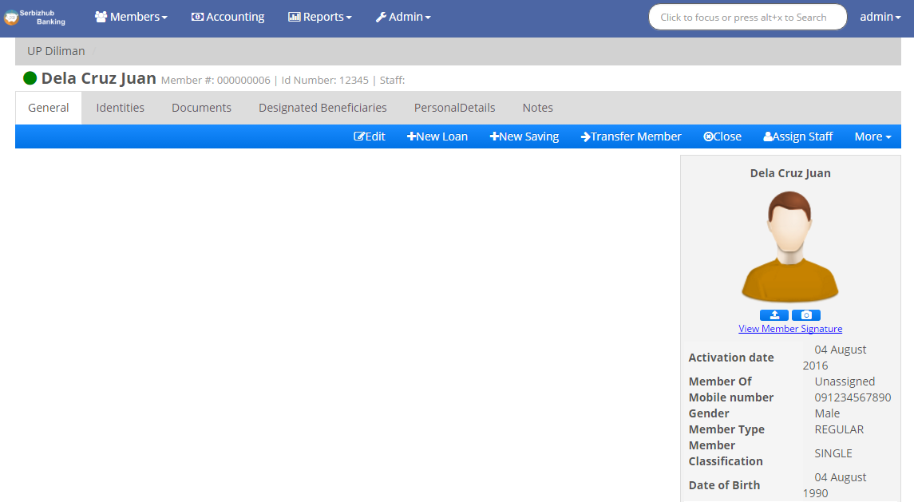

Figure 35. New Loan
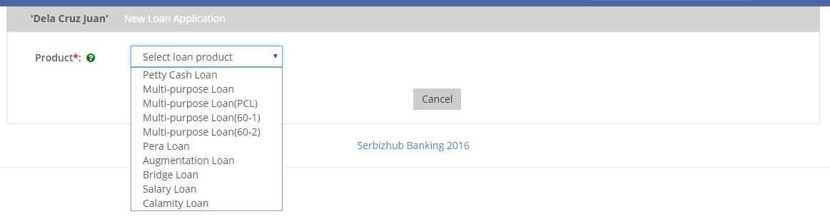

Figure 36. Selection of Loan Product available
Once the Loan Manager selected a loan product, an application form will appear. See Figure below.
Note: Creating a Loan Product will be discussed at the Administrator Module.
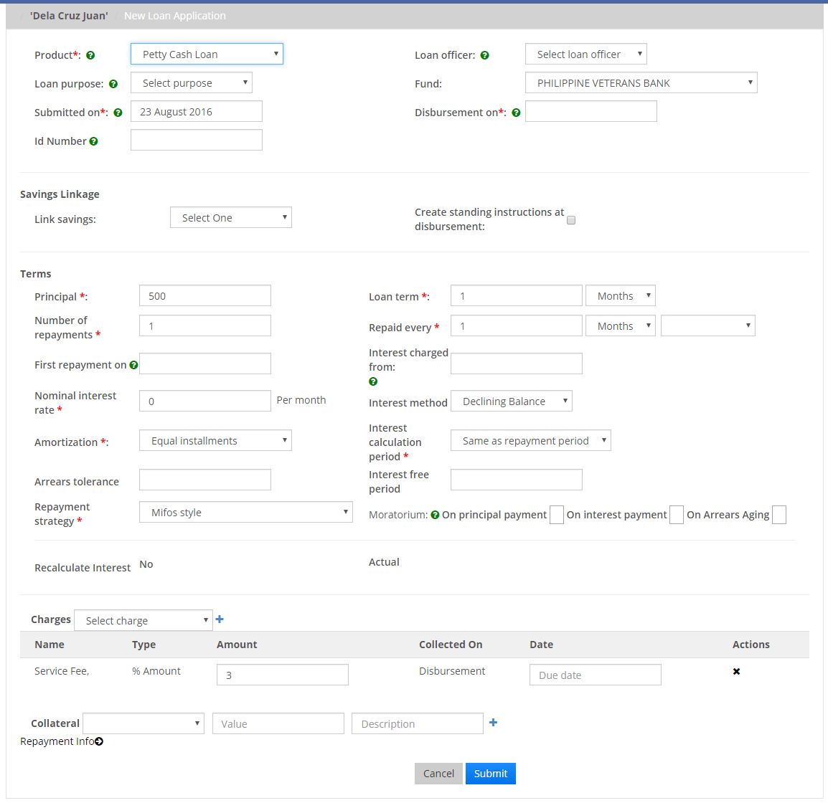
Figure 37. Loan application form
This will vary via loan product. Terms’ range in Principal, Loan Term, Interest and Charges will be predefined by the General Manager. However, the Loan Manager can insert additional charges from the “Charges” section. Loan product management will be discussed in Administrator Module.
Note: Once the loan is applied and there are fields to alter, the loan manager can also modify the loan application by clicking the “Modify Application” button. See Figure below.

Figure 38. Modify Application

Note: Loans can also be linked to the savings of the Member. This will disburse the loaned amount to the savings account. To link the loan to the savings, go to Member > Member > Name of the Member > New Loan > Savings Linkage ( Link to Savings).
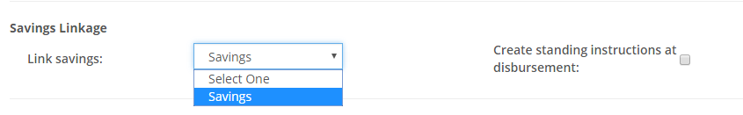
Figure 39. Savings Linkage

Approve Loan

After successfully submitting the application, the Loan account application will be created and its status will be pending for approval. It will now then be available for the approval of the General Manager.
There are two(2) ways to approve Loan.
First option to approve a loan is via clicking the “Approve” button.

Figure 40. Approve Loan
The second option is the click the “Check” button located at the profile of the Member.
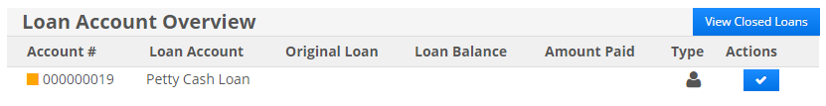

Figure 41. Alternative approve loan
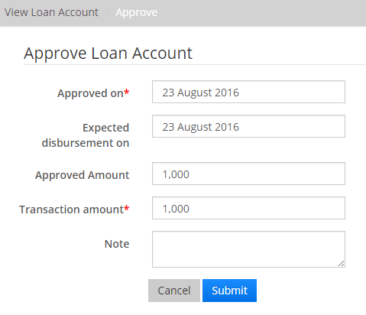
Figure 42. Submit Approval
Once the loan application is approved, it will then be ready for disbursal.
The General Manager can also undo the approval of loan by clicking “Undo Approval”. The user will be provided a field for note about the reason for undoing the loan approval. See Figure below.

Figure 43. Undo Approval
Note: The colored boxes indicate the status of a Loan:
For Waiting for Approval For Approved and Active
For Waiting for Disbursal For Closed
For Overdue For Loan connected to a Savings

4.3 Disburse Loan

Once the loan applied is already approved by the General Manager, it will then be available for disbursement. Disbursement feature can only be accessed and used by the user with “Cashiering” role.
To disburse a loan, go to Members > Members > Name of the Member > Loan to be Disbursed > Disburse button. See figure below.
Figure 44. Disbursal of Loan

Note: If loan is linked to savings, please refer to Figure 39, there will be a button “Disburse to Savings”.
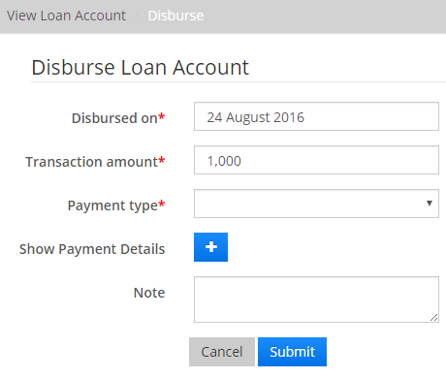
Figure 45. Disburse
Note: The cashier can also undo the disbursal just by clicking the “Undo Disbursal” button.
Figure 46. Undo Disbursal
Once the loan account is disbursed, the charges will automatically deduct with the net proceeds and it will reflect as “Paid” on the repayment schedule.
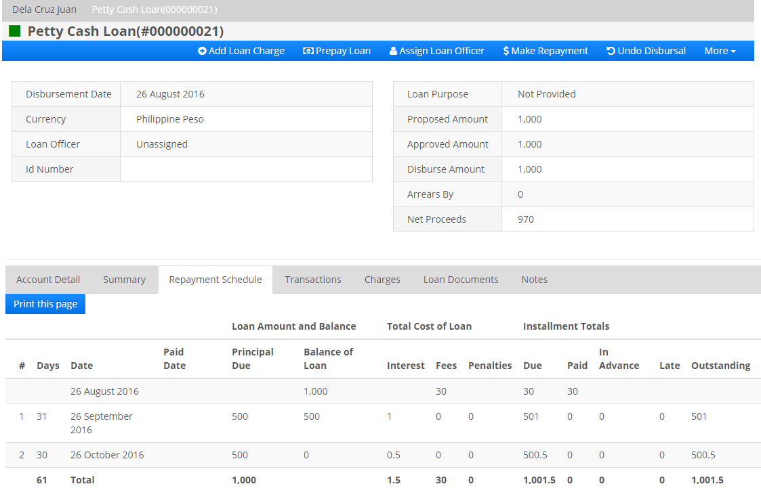
Figure 47. Repayment Schedule
Additional Feature: Printing of the Repayment Schedule that can also be used as Statement of Account. Click Print this Page. See Figure 47.
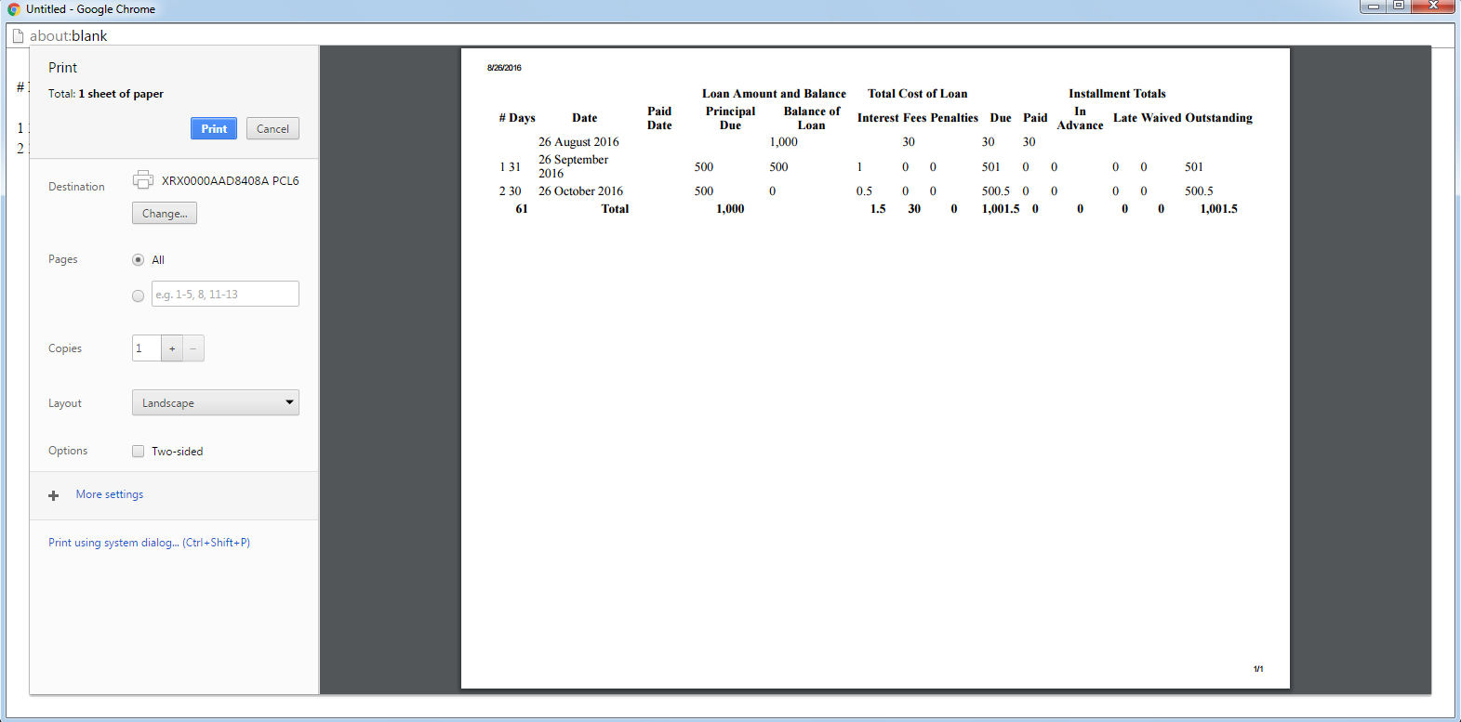
Figure 48. Printing of Repayment Schedule

4.4 Loan Transactions
Users that have access to Loan Management can also view the “Transactions” tab that shows the Transaction Type and Breakdown. Here is where the user can view the Receipt and Journal Entries.
To view loan transactions, go to Member > Member > Name of the Member > Loan Account > Transactions tab
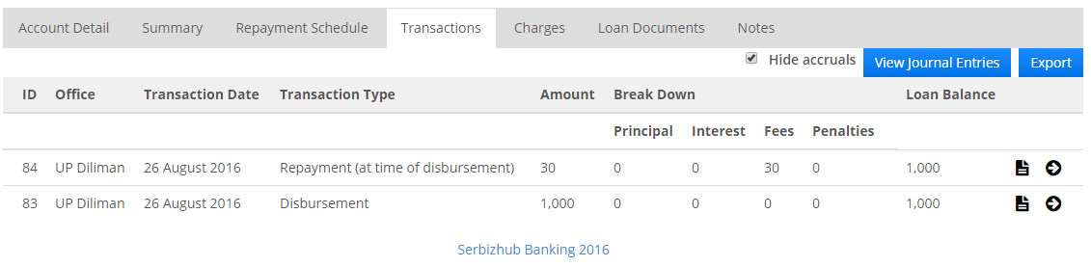

Figure 49. Transactions
To view the receipt per transactions, click the () icon. A page similar below will appear.
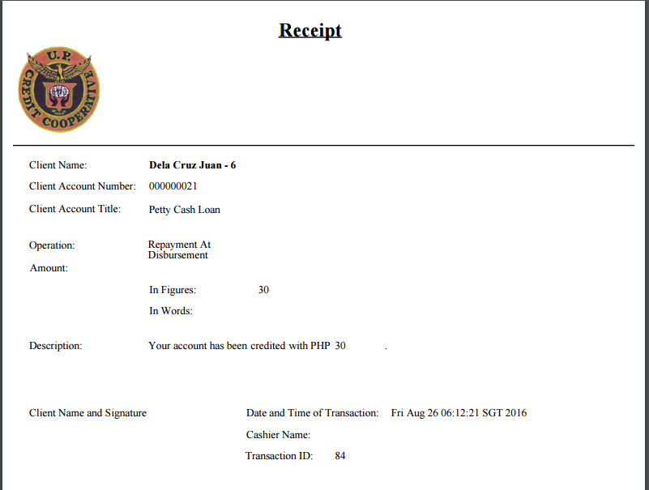
Figure 50. Loan Receipt

4.5 Charges

The user can also view and print the charges applied to a specific loan account. To view the charges, go to Member > Member > Name of the Member > Loan > Charges tab. This will show all the charges applied and how much is the payment per charge. See Figure 50.
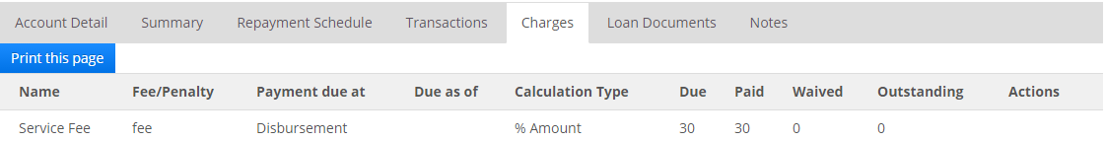
Figure 51. Charges
Charges can also be printed by clicking the “Print this page button”.
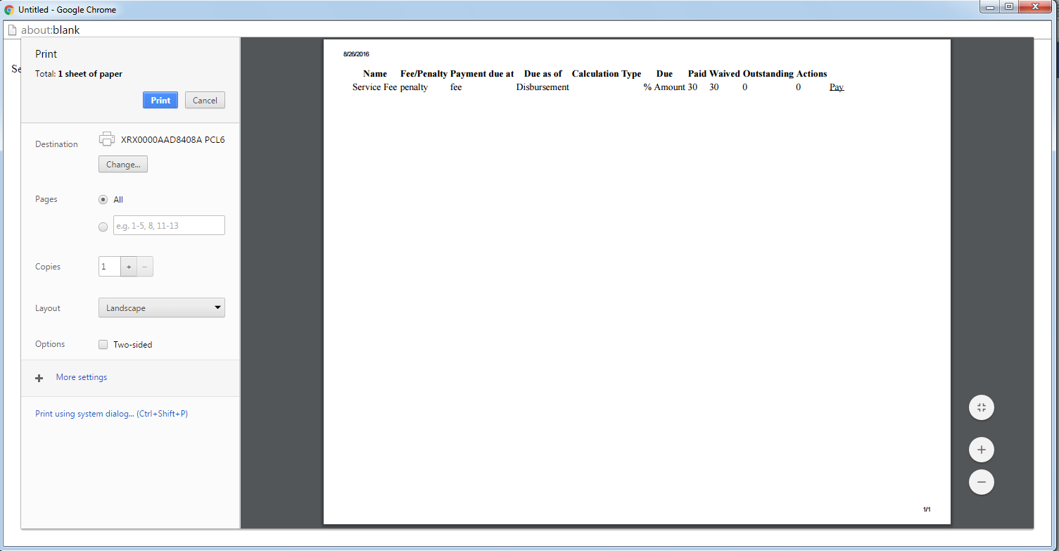
Figure 52. Printing the Charges

4.6 Adding Charges

Loan managers can also add charges to a loan account. To add charges, go to Member > Member > Name of the Member > Loan > Add Loan Charge.
Figure 53. Add Loan Charge
Note: A charge can only be added to an existing loan if the charge time method is not “Disbursement”. Charges with “Disbursement” charge time method must be added before the Loan is disbursed. See Figure below.
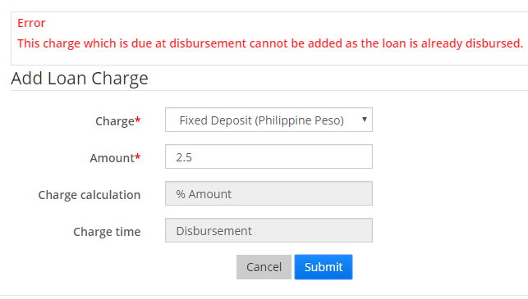
Figure 54. Adding Loan Charge Exception

4.6 Account Details

To view the details of a specific Loan account, go to Member > Member > Name of the Member > Loan > Account Detail tab. This tab will display all the necessary details inserted at loan application e.g. Interest, when the loan was approved, disbursed and maturity.
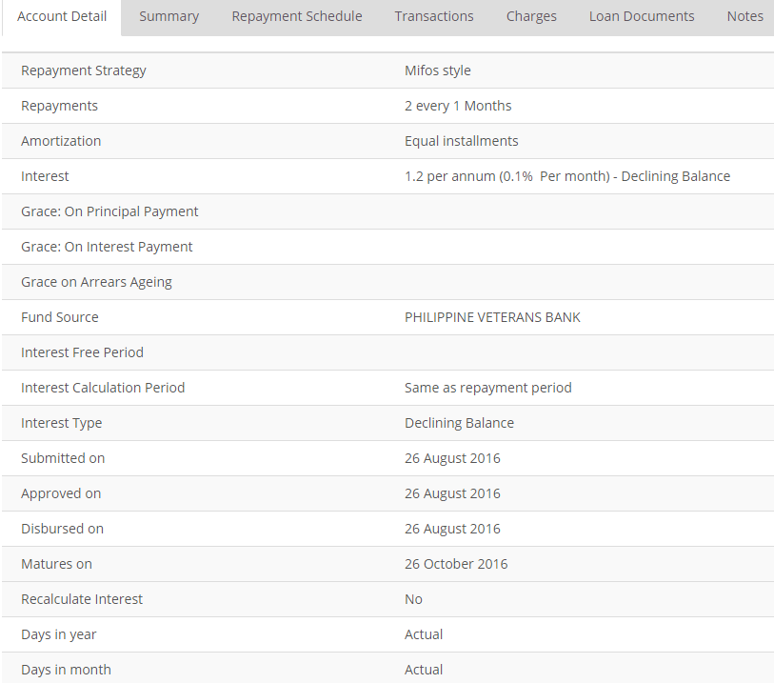
Figure 55. Account Details

4.7 Loan Documents

The user can also upload documents on a specific loan. To upload loan documents, go to Member > Member > Name of the Member > Loan > Loan Documents Tab > Upload.

Figure 56. Loan Documents
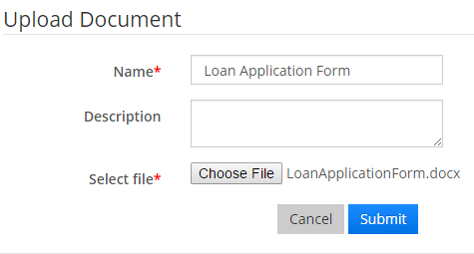
Figure 57. Upload Loan Documents
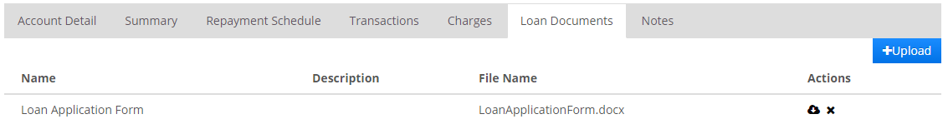

Figure 58. Sample Loan Document
Click the download icon () to save the uploaded document to your computer or the delete icon () to delete the uploaded document.

4.8 Prepay Loan

To have an early payment of the loan, go to Member > Member > Name of the Member > Loan > Prepay Loan. Fill in all the required fields then click Submit.

Figure 59. Prepay Loan
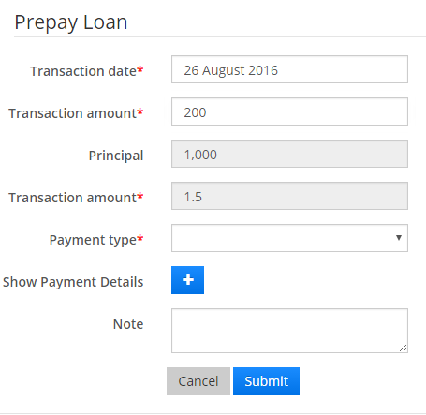
Figure 60. Prepay Loan
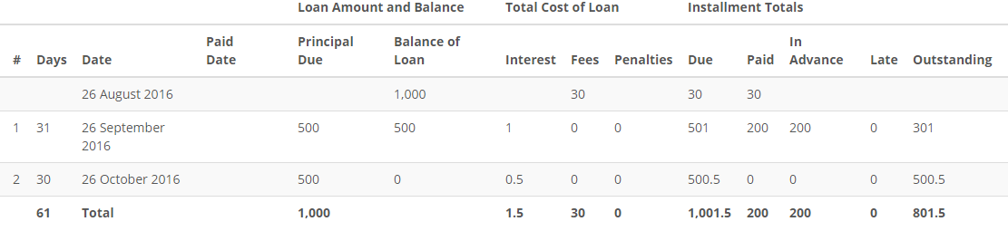
Figure 61. Prepay Loan Submitted

4.9 Assign Loan Officer

To assign Loan Officer to a Loan account, go to Member > Member > Name of the Member > Loan > Assign Loan Officer. Select a loan officer from the drop-down menu then click Submit.

Figure 62. Assign Loan Officer
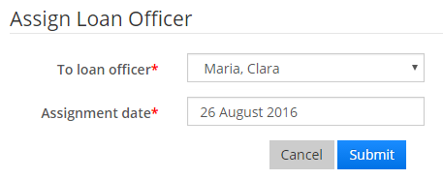
Figure 63. Loan Officer

Make Repayment

To make a loan repayment, go to Member > Member > Name of the Member > Loan > Make Repayment.

Figure 64. Make Repayment

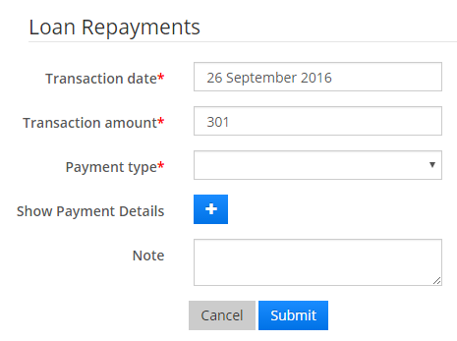

Figure 65. Loan Repayments
Transaction Amount will display the amount that should be collected on that month. Transaction amount field can be modified to how much the loaner wants to pay.
By clicking the Add button (), fields for payment details will appear. These are not mandatory fields.
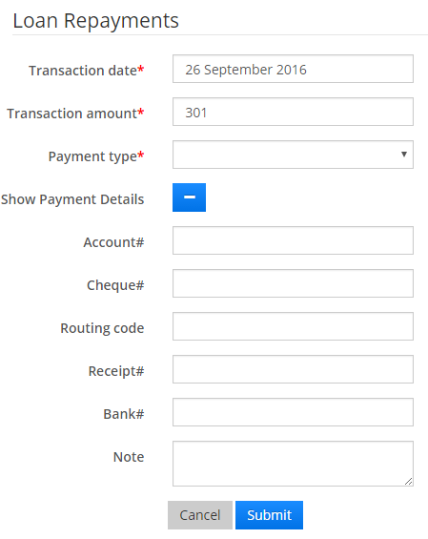

Figure 66. Payment Details

5.1 Guarantors

Number of guarantors per loan is specified by the Loan Manager. The total count of loan guaranteed by a member can be viewed at the Reports Module, go to the Reports Module for further discussion.
To create a guarantor, go to Member > Member > Name of the Member > Loan > More. A dropdown menu will appear. Please refer to the figure below.
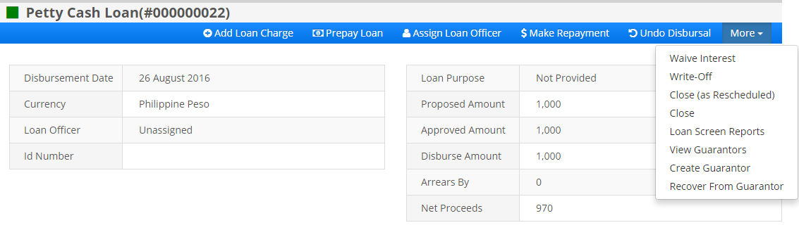

Figure 67. Drop-down Menu
Click the Create Guarantor from the drop-down menu; fill in all the required fields then click Submit.
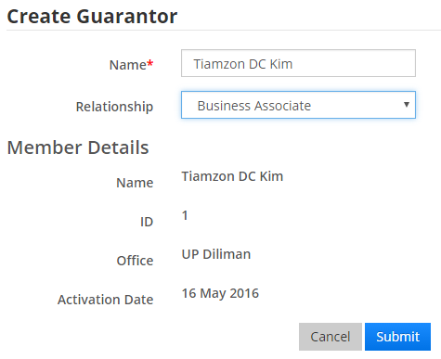
Figure 68. Create Guarantor
Once the guarantor is created, it will display at the View Guarantor page. To view guarantors, go to Member > Member > Name of the Member > Loan > More > View Guarantor

Figure 69. View Guarantors
Click the Eye icon () at left right side to view the details of the guarantor and/or the Bin icon
() to delete the guarantor.

To recover from the guarantors created, go to Member > Member > Name of the Member > Loan > More > Recover from Guarantor. The figure below will appear
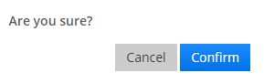
Figure 70. Recover from Guarantor

5.2 Waive Interest

To waive interest, go to Member > Member > Name of the Member > Loan > More > Waive Interest. This will waive the interest of the next repayment scheduled.
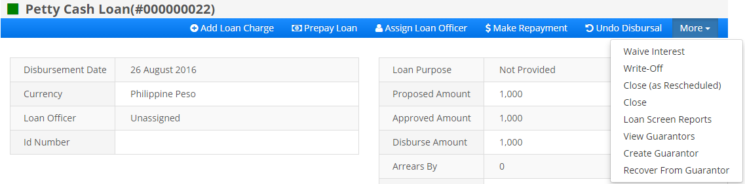

Figure 71. Waive Interest
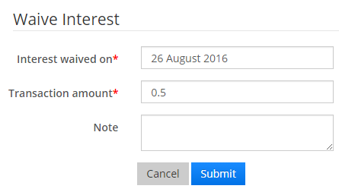
Figure 72. Waive Interest
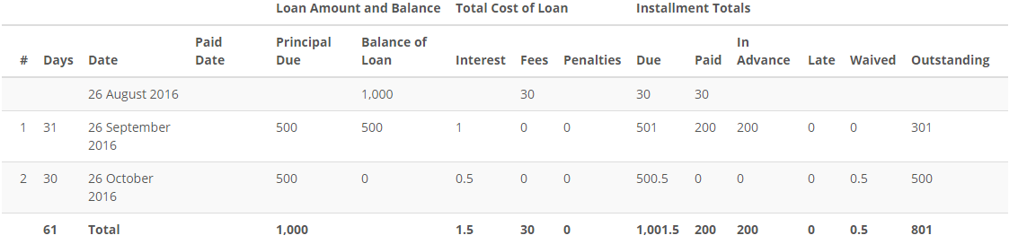

Figure 73. Waived Interest
Note: An error message will appear if the amount of the interest waived exceeds the outstanding interest on loan.

5.3 Write off Loan

If the member wants to write-off a specific loan account, go to Member > Member > Name of the Member > Loan > More > Write-off. Fill the required details then click Submit. Transaction amount field will automatically display the remaining balance of the Loan.

Figure 74. Write-off
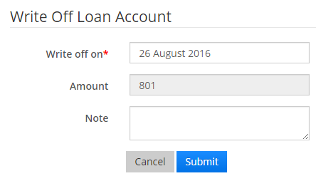
Figure 75. Write-off Loan Account

5.4 Close (as Rescheduled)

To close a loan account that is rescheduled, go to Member > Member > Name of the Member > Loan > More > Close(as Rescheduled). Select close date and note if there are any, then click Submit

Figure 76. Close (as Rescheduled)

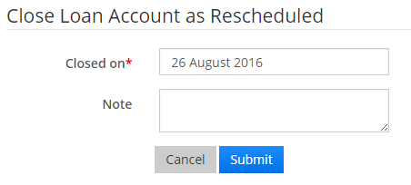
Figure 77. Close Loan Account as Rescheduled

5.5 Close Loan Account

To close a loan account, go to Member > Member > Name of the Member > Loan > More > Close. Fill in the date of close and add note if there are any.

Figure 78. Close Loan Account
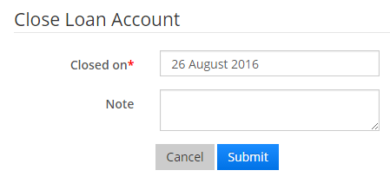
Figure 79. Close Loan Account
Note: The user cannot close a loan account if the outstanding balance is not yet settled.


5.0 Savings

This module lets the member open a savings account in the system. Initially, this is only accessible to loan manager and General Manager.

5.1 New Savings

To apply for a new savings account, go to Member > Member > Name of the Member > New Savings.

Figure 80. New Savings
When clicked, there will be a drop-down menu that will let the Loan Manager select savings product to apply. Once selected, an application form will be displayed on the page.
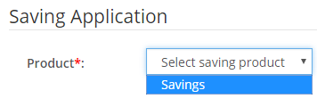
Figure 81. Savings Application
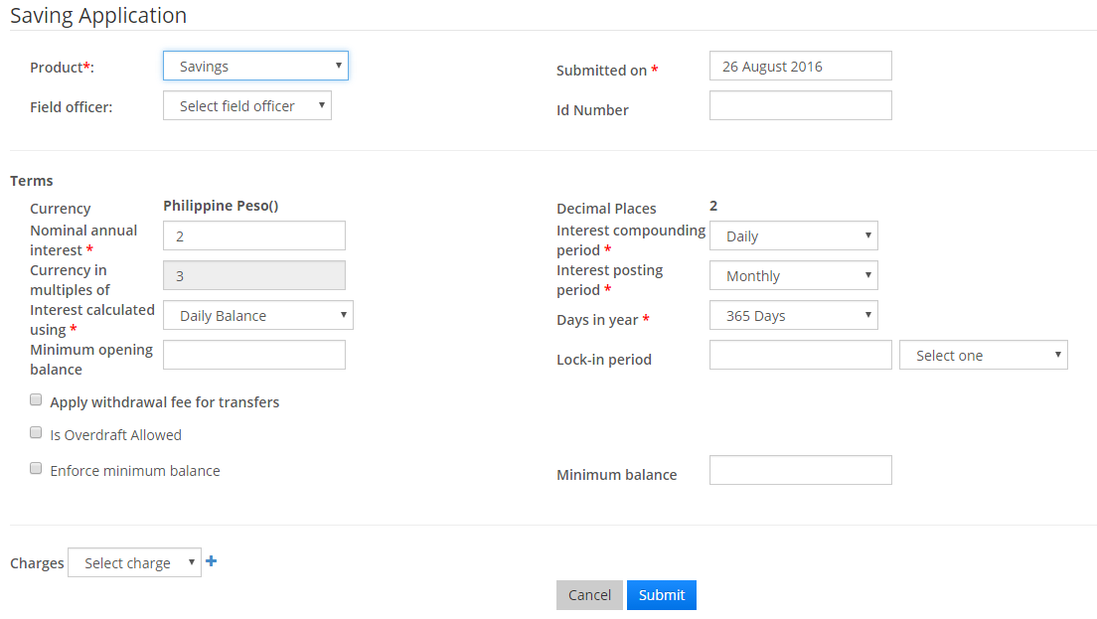Figure 82. Savings Application Form
After successfully submitting the application, the savings account will be created and its status is pending for approval.

5.2 Manage Savings

The Loan Manager can also modify the Savings account applied. Click the Modify Application button and it will redirect to the application form

Figure 83. Modify Savings Application Form

5.3 Approve Savings

To approve a Savings Applied, go to Member > Member > Name of the Member > Savings > Approve. Fill in all the approval date then click Submit. Another way to approve savings is by click the check icon (). Approve Savings button is only available for the General Manager.

Or
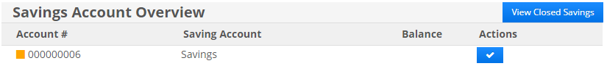

Figure 84. Approve Savings
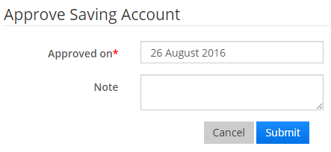
Figure 85. Approve Saving Account
Note: General Manager can undo the approval of a savings account by clicking the “Undo Approval” or by clicking the icon () located in the Members’ dashboard.

5.4 Activate Savings

To activate a savings account, go to Member > Member > Name of the Member > Savings Account > Activate or click the check icon (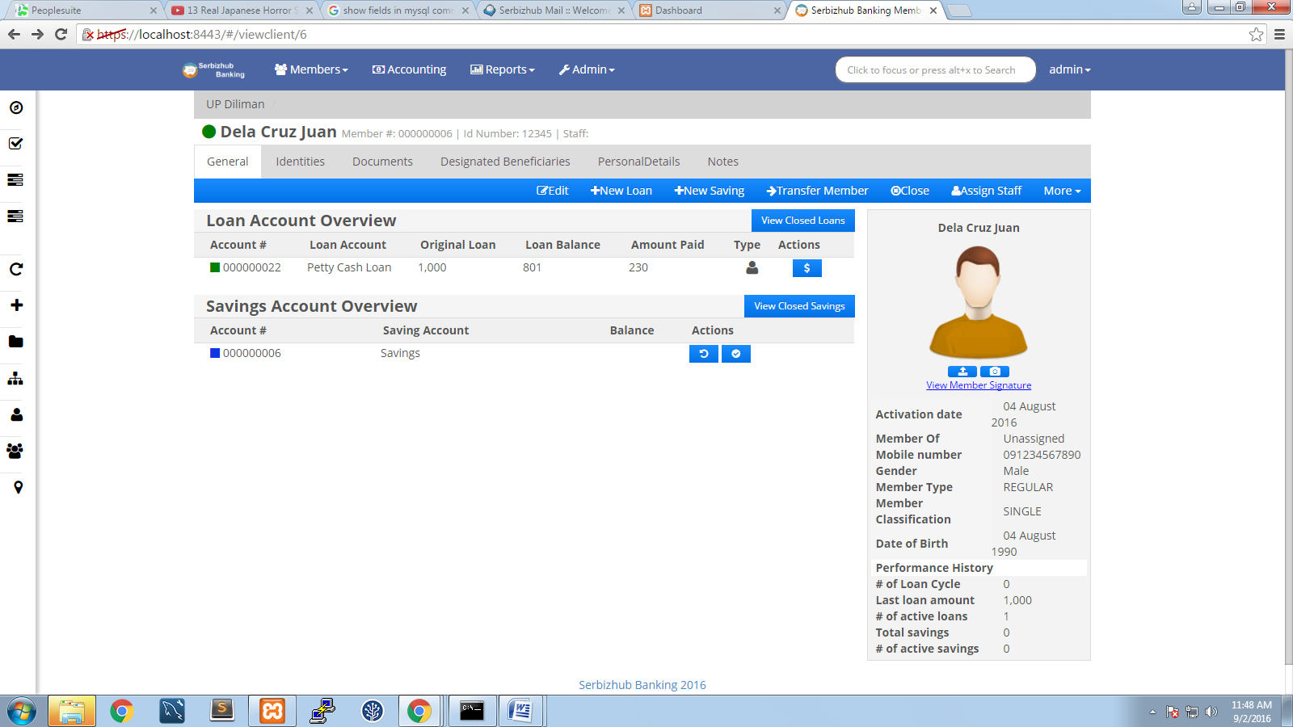) located at the dashboard of the member.
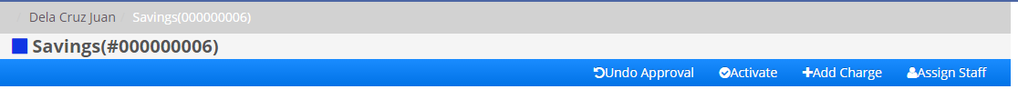

OR

Figure 86. Activate Saving Account

Table of Contents
1.0 Audience 2
2.0 The System 3
2.1 Installation and Logging In 3
2.2 User Roles 4
2.3 Modules 5
3.0 Membership 6
3.1 View Member 6
3.2 Manage Member 7
3.2.1 Create Member 7
3.2.2 Edit Member 9
3.2.3 Upload Members’ Image 10
3.2.4 Upload Members’ Signature 12
3.2.5 Add Identities 13
3.2.6 Adding Documents 14
3.2.7 Adding Beneficiaries 15
3.2.8 Adding Personal Details 16
3.2.9 Adding Notes 17
3.2.10 Changing Members’ Status 18
3.2.11 Transfer Member 19
3.2.12 Assign Staff 20
4.0 Loan Management 21
4.1 New Loan 21
4.2 Approve Loan 23
4.3 Disburse Loan 24
4.4 Loan Transactions 26
4.5 Charges 27
4.6 Adding Charges 27
4.6 Account Details 28
4.7 Loan Documents 29
4.8 Prepay Loan 29
4.9 Assign Loan Officer 30
5.0 Make Repayment 31
5.1 Guarantors 32
5.2 Waive Interest 33
5.3 Write off Loan 34
5.4 Close (as Rescheduled) 34
5.5 Close Loan Account 35
5.0 Savings 36

